**MEC 104 Lab Report**

**Group:** A32

**Members:** Ding Wang (1927804); Zhongnan Li (1931254); Chenruiyuan Yu (1928118)

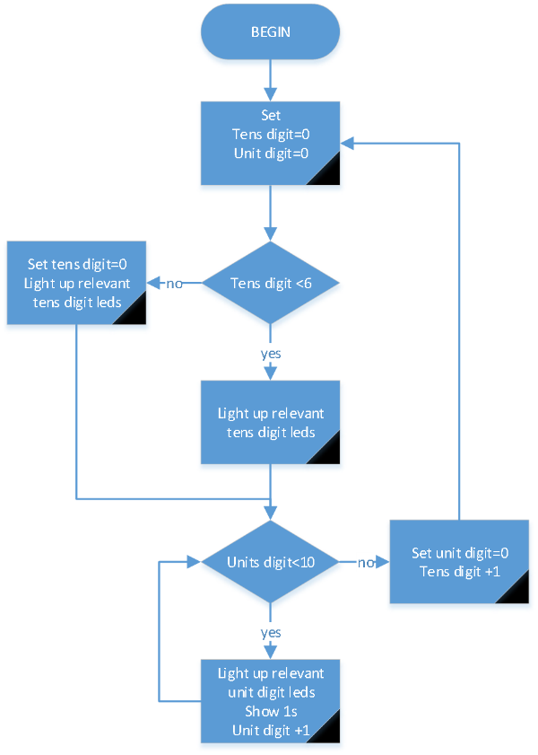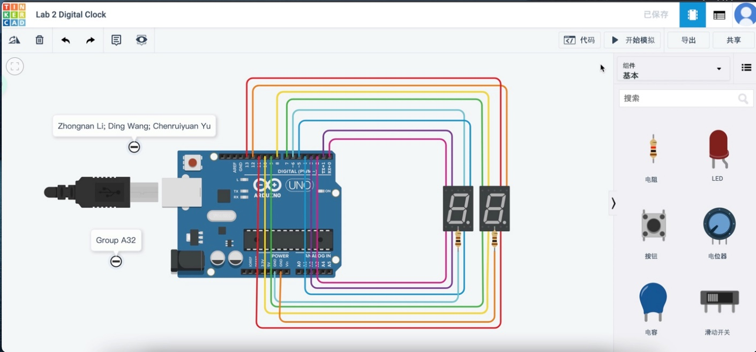**<- Schematic diagram**

**Working principles:**

In the system, for each LED light, the program decides whether to light up. For example, the ‘a’ LED light will be light up when we need to show 0,2,3,5,6,7,8,9; the ‘b’ light will be light up when we need to show 0,1,2,3,4,7,8,9. Compare with control the LED lights by coding on the numbers, using 16 functions, coding on the LED lights only need 14 fractions.

To show each number, the tens digit is first to be judged. Each LED light in tens digit will be judged separately and keep the lights on. Then, the units digit is judged by the corresponding number whether to light up and keep for a second.

After a display process, the units digit will be added one and then judged by the program whether it is less than 10. If not, the units digit will be reset to 0 and add one to the tens digit. The tens digit will then be judged whether it is less than 6. If not, the tens digit will be reset to 0. After these steps of judgement, the SSD will be showed and continue.

**Problem met during the experiment:**

During the testing process, we found that a LED light which is unit digit ‘a’ LED light cannot work. We set the out put line to a new SSD alone, everything worked well. It shows that the code and the circuit has nothing wrong. Later, we changed the resistor from 500 $Ω$ to 200 $Ω$, everything worked well. We considered the error comes from the slight difference between each LED light since it is a diode. It can also be the problem of the simulation program.

**Contribution of each group member:**

All three members of our team participated in the conception of the program and jointly completed the conception of the program logic. Among us, Chenruiyuan Yu is mainly responsible for the implementation of the code, Zhongnan Li is mainly responsible for the design of the circuit, and Ding Wang is mainly responsible for the writing of the report.